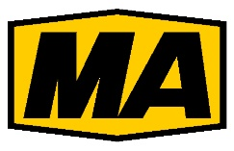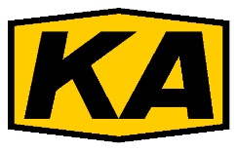
Certification Management Limited (CML) is proud to announce a market-changing mutual agreement with the Mining Products Safety Approval and Certification Centre (MA Centre) in Beijing. This critical agreement sees CML become the only UK certification body that can enable mining machinery manufacturers to promote and sell products into the Chinese mining market. All previous arrangements and cooperation agreements that the MA Centre had with other certification bodies have been cancelled.
The new agreement means that CML’s test data will be accepted by MA Centre. Without the MA Centre approval, mining equipment cannot be sold in China. This lucrative market for the mining equipment will continue to be accessible with the assistance of CML.
The MA Centre certificates expire after five years and products must be re-certified. Manufacturers who have previously obtained MA Centre approval based on certificates (including those for component parts) from other certification bodies will no longer be accepted by MA Centre. Please contact CML before certificate expiry to ensure continuity of trade in China
CML is making further arrangements with MA Centre in order to assist EU manufacturers access the Chinese mining market. Anyone affected by the changes at MA Centre should contact CML and discover how re-certification can be planned and experience the benefits of working with a responsive, credible certification body. In addition, CML can provide invaluable technical advice for ATEX / IECEx and North American approvals for companies globally. In many instances CML can offer “in country” support and local surveillance auditors for QAN and QAR inspection and audit requirements.

Contact CML for Chinese mining product approvals on
0151 559 1160, sales@cmlex.com
Or via our new website
www.cmlex.com

